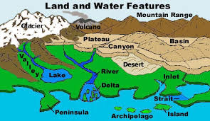
Landforms

Must Do’s: | Check When Done ✔
Plate Tectonic Puzzle
Landform Matching WS
Brainpop: Fossils
Watch the Brainpop video and do quiz
Score on quiz ________________%

Can Do’s: | Check When Done ✔
StudyJams- Landforms
- Video
- Learn the song
- Quiz
BrainPop Jr.- Match the Landforms jr.brainpop.com/science/land/landforms/matching
Picture Smart: Create your own “Pangaea” using clay
Word Smart: Create a myth about life on Pangaea. Publish and share!

Must Do’s: | Check When Done ✔
Plate Tectonic Puzzle
Landform Matching WS
Brainpop: Fossils
Watch the Brainpop video and do quiz
Score on quiz ________________%

Benchmarks
Nystrom Lesson 11: Landforms
Grand Canyon Video (2:51)
http://www.pbslearningmedia.org/resource/ess05.sci.ess.earthsys.nautiloid/the-grand-canyon-evidence-of-earths-past/

