Bringing Recognition to the Lenape Tribe
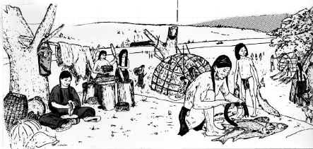
- Do you like to eat corn, potatoes, sunflower seeds, and peanuts?
- Have you seen people with the Mohawk haircut?
- Have you seen a mom carrying her baby on her back?
These items and traditions can be traced back to the original residents of New Jersey, the Lenni Lenape Native American Tribes.
These tribes have traditions, which have survived to the present today. But have you ever seen a Lenni Lenape here today? You haven't. That's because the colonists who came to this area and took away their land.
This happened to all of the different tribes of Native Americans that once lived across North America. To make amends for this poor treatment, the United States provides reservations (protected lands for the tribes) and gives money to support education and businesses for those tribes of Native Americans still alive today.

However, in New Jersey and Pennsylvania the Lenni Lenape are not officially recognized as a tribe by the United States. Is this fair? Why would the government think this? Should the Lenni Lenape tribes, who have shaped the culture in the eastern United States, have that recognition?
In January of 1992, the Nanticoke-Lenni Lenape tribe sent a letter to the Bureau of Indian Affairs asking to be recognized by the US as an Indian Tribe. The bureau has still not made a decision. That’s a long time to wait for an answer.
Given that their traditions are a large part of our daily lives today, it is time for you to investigate this issue further and form your own opinion.

