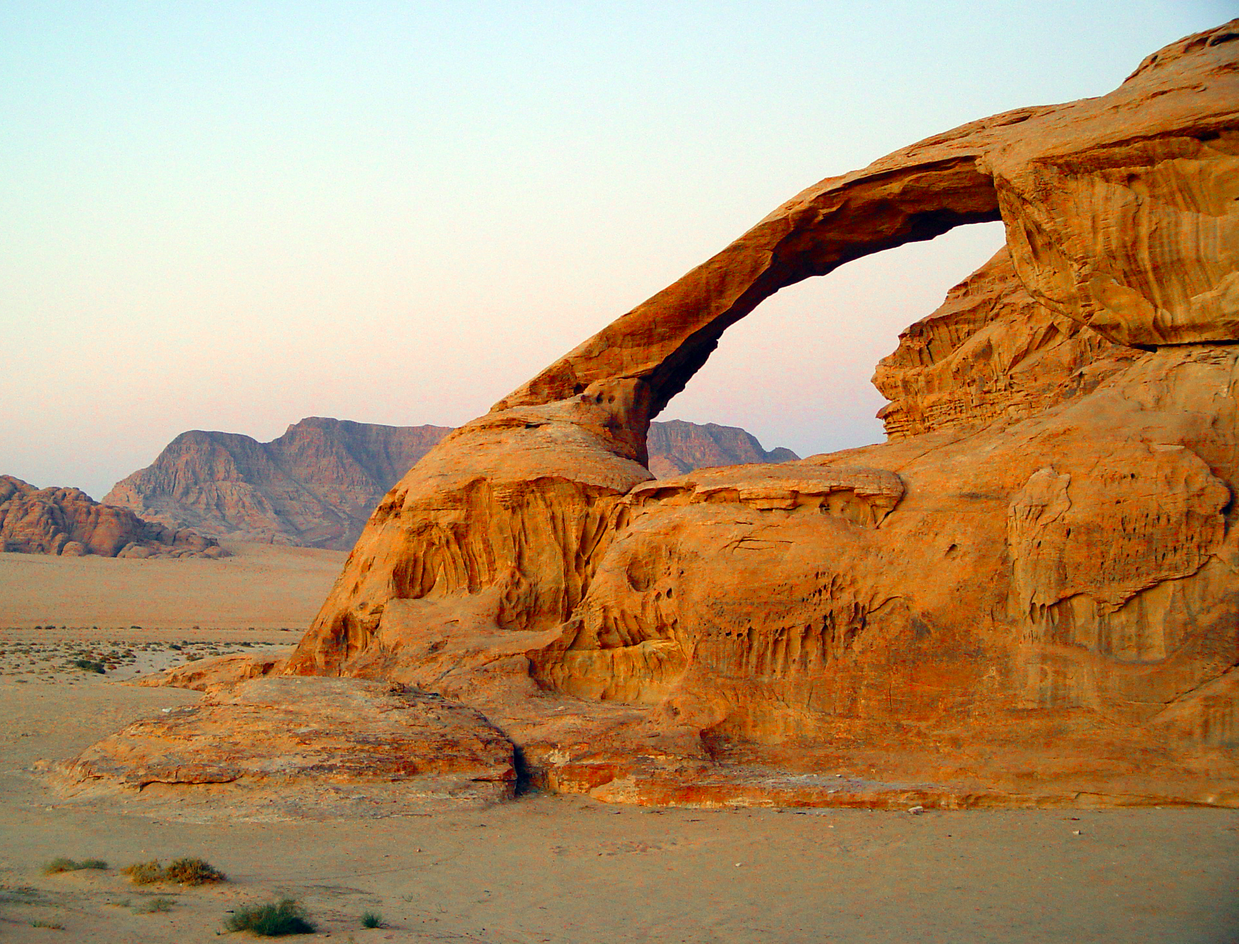
Weathering and Erosion

Can Do’s: | Check When Done ✔
StudyJams- Fossils
- Video
- Quiz
Nature Smart: Earth Changing Erosion Game:
http://sciencenetlinks.com/interactives/shapeitup.html
Brainpop: Weathering
Watch the Brainpop video and do quiz
Score on quiz ________________%
Picture Smart: Erosion Game
http://www.nps.gov/webrangers/activities/rockpark/

Benchmarks
Studyjams: Weathering and Erosion
Nystrom Lesson 9: Physical Maps

Must Do’s: | Check When Done ✔
Breaker and Whoosh Comic
Mammoth Fossil Found Article
Brainpop: Erosion
Watch the Brainpop video and do quiz
Score on quiz ________________%
Erosion Types WS (Brainpop)

